Book

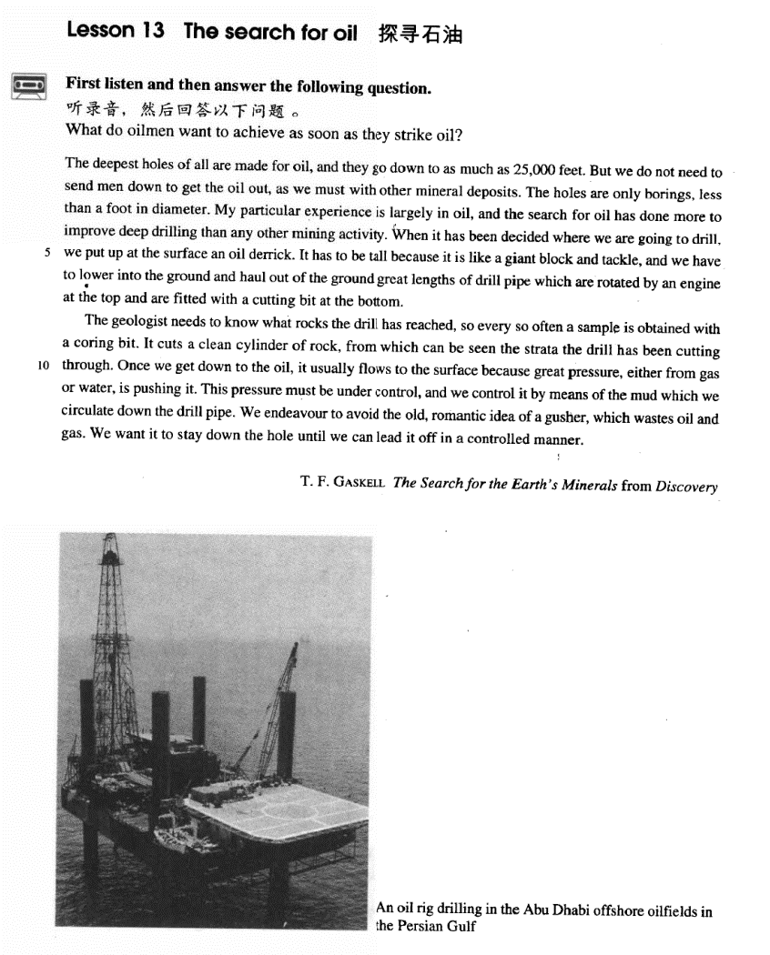

课文

The deepest holes of all are made for oil, and they go down to as much as 25,000 feet.

在所有洞穴中，为寻找石油所钻出的洞是最深的，这些洞可深达25,000英尺。

But we do not need to send man down to get the oil out, as we must with other mineral deposits.

但是，我们不必像开采其他矿藏那样，把人送到地下去把石油取出。

The holes are only borings, less than a foot in diameter.

这些洞只不过是一些钻孔，直径不到1英尺。

My particular experience is largely in oil, and the search for oil has done more to improve deep drilling than any other mining activity.

我是专门搞石油的，寻找石油比其他任何采矿业对改进钻探作的贡献都要大。

When it has been decided where we are going to drill, we put up at the surface an oil derrick.

当确定钻孔地点后，我们就在那里竖起一个井架。

It has to be tall because it is like a giant block and tackle and we have to lower into the ground and haul out of the ground great lengths of drill pipe which are rotated by an engine at the top and are fitted with a cutting bit at the bottom.

井架必须很高，因为它像一个巨型滑轮组。我们必须把很长的钻杆一节节地钻入地下，然后再从地下拉出来。钻杆顶部安装的发动机带动钻杆旋转，它的底部装有钻头。

The geologist needs to know what rocks the drill has reached, so every so often a sample is obtained with a coring bit.

地质学家需要知道钻头已以到达什么样的岩层，因此时常要用芯钻头取样。

It cuts a clean cylinder of rock, from which can be seen the strata the drill has been cutting through.

这种钻头能切割一段光滑的圆柱形岩石，从中能看出所钻透的地层。

Once we get down to the oil, it usually flows to the surface because great pressure either from gas or water, is pushing it.

一旦到达油层，石油就会由于地下巨大的压力流到地面上来，这种巨大的压力来自地下天然气或水。

This pressure must be under control, and we control it by means of the mud which we circulate down the drill pipe.

这种压力必须加以控制，我们让泥桨顺着钻杆向下循环，用这种方法来控制压力。

We endeavour to avoid the old, romantic idea of a gusher, which wastes oil and gas.

我们尽量避免使用陈旧天真的喷井方法，那样会浪费石油和天然气。

We want it to stay down the hole until we can lead it off in a controlled manner.

我们要让石油留在井下，直到我们能用一种有控制的方法把它引上来为止。

词汇讲解

Lesson 13 The search for oil

mineral ['mɪnərəl]

adj. 矿物质的；n. 矿物质

mineral resources / spring / water / substance / deposits

China is rich in minerals. metallic minerals

non-metallic minerals

ore iron ore uranium ore mine a coal-mine a gold-mine boring ['bɔ:rɪŋ]

n. 钻孔；钻出的孔

bore bore a hole in wood

bore a tunnel through the mountain

drill drill for oil / water

an electric drill perforate

Perforate the cover to let air in. punch

prick / pierce

A small bead of blood formed where she had pricked her finger. She had her ears pierced.

haul [hɔ:l]

v. （持续而缓慢地）拖拉或提升

Rescue workers attached the men to ropes before hauling them to safety.

drag

He dragged the heavy chest across the floor.

The police dragged the soccer hooligan off the pitch. tow

My car broke down and had to be towed to a garage. trail

She walked slowly along the path, her skirt trailing in the mud. tug

We tugged it so hard that the rope broke. pull / draw

rotate [rəʊ'teɪt] ['roʊteɪt]

v. （使）（沿自身的轴）旋转

rotate the handle gently revolve

The restaurant revolves slowly, giving excellent views of the city. The earth rotates on its axis while it revolves in its orbit.

spin

The ice skater began to spin faster and faster. twirl

The couple was twirling to a waltz. circulate

Blood circulates through the body.

Open the window to allow the air to circulate. circulation

geologist [dʒi'ɒlədʒɪst]

n. 地质学家

geologist geology

“*geo*” = earth + “*logy*”= to study

geological geologically

From the shore-line out to a distance which may be anywhere from a few miles to a few hundred miles runs the gentle slope of the continental shelf, geologically part of the continents.

geographer geography “*geo*” + “*graphy*” = to write geographical geographically geometry

“*geo*” + “*metry*” = to measure solid geometry

strata ['strɑ:tə] ['streɪtə]

n. 岩层；社会阶层

people of different social strata

stratum ➔ strata datum ➔ data medium ➔ media bacterium ➔ bacteria

curriculum ➔ curricula

|  |  |
| --- | --- |
| Bore/drill a hole | Prick a hole |
| Punch a hole | Dig a hole |
| Knock a hole | Chop a hole |
| Eat a hole | Gnaw a hole |
| Make a hole | |

I’ll go down to Hangzhou tomorrow. I’ll go up to Dalian tomorrow.

go down to the countryside go up to town

go down to as much as …

The platforms extend to a depth of over 100 feet under the sea.

The deepest known cave in the world is the Gouffre Berger near Grenoble. It extends to a depth of 3,723 feet.

extend to a depth of …

She stood three feet high and her hands rested on her hips. stand … high

Above the surface of the water, the towers rise to a height of nearly 700 feet.

rise to a height of … How do I love thee? How do I love thee? Let me count the ways.

I love thee to the depth and breadth and height my soul can reach. Elizabeth Barrett Browning

But we not need to send men down to get the oil out, as we must with other mineral deposits.

send sb. to do sth. send sb. to sth.

send the boy to buy some beer send the boy to school / bed

dispatch sb. to do sth. dispatch sb. to sth.

The government dispatched 100 police to restore order. An ambulance was immediately dispatched to the area. transfer sb. to sth.

He was transferred to our Shanghai branch. post sb. to sth.

He was posted to the embassy in London.

transport sb. to sth.

He was transported to Siberia for life.

…, as we must send men down with other mineral deposits. less than+数词+计量名词(时间；距离；金额)

less than 20 minutes / a foot / 2 miles / 10 dollars

fewer than+数词+普通名词

There are fewer than 20 applications.

The whole of Switzerland has fewer than six million inhabitants. no less than+数词+计量名词(时间；距离；金额)

“足足有……；有……之多”

not less than+数词+计量名词(时间；距离；金额) “至少有……；不少于……”

He won no less than $1,000,000 in the lottery. He won not less than $1,000,000 in the lottery.

no fewer than+ 数 词 + 普 通 名 词

“足足有……；有……之多”

not fewer than+数词+普通名词 “至

少有……；不少于……”

No fewer than a thousand people came. Not fewer than a thousand people came. no more than … 只有……

not more than … 最多……

No more than 20 people are present. Not more than 20 people are present. diameter

“*dia*”= across + “*meter*”/“*metry*”= measure radius

caliber / calibre

particular adj. specific; individual in this particular case

= in this specific case his particular problems

= his individual problems

largely adj. chiefly / mainly / to a great extent

His success was largely due to luck. do much / a lot / a great deal to … do little to …

do nothing to …

Though he was technically a prizefighter, Mendoza did much to change crude prizefighting into a sport, for he brought science to the game.

造句：尽管严格地说只是一本书，但圣经在把这个粗鄙的世界变成一

个文明世界方面却做出了很大贡献，因为它给人类带来了信仰(faith)。Though it is technically a book, the Bible does much to change the crude world into a civilized one, for it brings faith to humanity.

do more to … than …

造句：新概念英语比其他任何书对提高我写作能力的作用都大。New Concept English has done more to improve my writing skills than any other book.

When it has been decided where we are going to drill, we put up *at the*

*surface* an oil derrick. put up: set up; erect

It has to be tall because it is like a giant block and tackle, and we have to lower *into the ground* and haul *out of the ground* great lengths of drill pipe which are rotated by an engine at the top and are fitted with a cutting

bit at the bottom.

… we have to lower *great lengths of drill pipe which are rotated by an*

*engine at the top and are fitted with a cutting bit at the bottom* into the ground and haul *them* out of the ground …

It has to be tall because it is like a giant block and tackle, and we have to lower *into the ground* and haul *out of the ground* great lengths of drill pipe which are rotated by an engine at the top and are fitted with a cutting

bit at the bottom.

造句: 请把我们急需的那个软件从网站上下载下来然后通过e-mail 发送给我。

Please download *from the website* and send *to me by email* the software of which we are in urgent need.

a length of rope

a bar of chocolate a loaf of bread

a cone of ice-cream

a bunch of grapes / bananas

a cake of soap

a flash / bolt of lightning a peal of thunder

a gust of wind a pane of glass

a bouquet of flowers a *nice* cup of tea

a *beautiful* stretch of field a *stagnant* pool of water

The geologist needs to know what rocks the drill has reached, so every so

often a sample is obtained with a coring bit. every so often sometimes occasionally at times

(every) now and then (every) now and again once in a while

from time to time

It cuts a clean cylinder of rock, from which can be seen the strata the drill

has been cutting through.

… from which the strata the drill has been cutting through *can be seen*. Once we get down to the oil, it usually flows to the surface because great pressure, either from gas or water, is pushing it.

Let’s get down to business. work.

fundamentals / basics.

This pressure must be under control, and we control it *by means of the mud which we circulate down the drill pipe*.

be under control

get sth. under control

The air will be cleaner if they go to a different city.

It’ll soon be too late to control the pollution.

Society will not pay attention to the new laws.

The situation will improve if changes are made.

M: Look at all the pollution going into the air from those factories. Do you think they’ll ever get that under control?

W: With the new laws and social awareness, we’ll turn things around. Q: What does the woman predict will happen?

Answer: (D) The situation will improve if changes are made.

get out of control / hand

A day may begin well enough, but suddenly everything seems to get out of control.

Discuss the situation with the person in charge of the dormitory.

Ask her roommate not to make so much noise.

Go to bed after midnight.

Send a letter to the residents.

W: You know the noise in my dorm has really gotten out of control. My roommate and I can rarely get to sleep before midnight.

M: Why don’t you take the problem up with the dorm supervisor? Q: What does the man suggest the woman do?

Answer: (A) Discuss the situation with the person in charge of the dormitory.

We started burning some leaves in our yard, but the fire got and we had to call the fire department to put it out.

out of hand

out of order

out of the question

out of the way

The car is under repair. The castle is under attack.

The subject is under discussion.

The matter is under consideration. You are under arrest.

The patient is under observation. The case is under investigation. The bridge is under construction. The building is under renovation.

We endeavour to avoid the old, romantic idea of a gusher, which wastes oil and gas.

endeavor to do

make every endeavor to do go to great lengths to do

The man went to great lengths to prove that the diamonds were real. spare no effort to do

China will spare no effort to realize peaceful reunification. do / try one’s best / utmost to do

Though the doctor did his best, the patient's recovery was slow.

You play to win, and the game has little meaning unless you do your utmost to win.

give one’s all to do go all out to do

They should wait for John to bring the dessert.

He thinks John must have spent a lot of money for the dinner.

The dessert also looks impressive.

He helped John make the sandwiches.

W: Look at the delicious sandwiches. John’s really gone all out this time. M: Just wait until you see the dessert.

Q: What does the man imply?

Answer: (C) The dessert also looks impressive. romantic adj. impractical

We can read of things that happened 5,000 years ago in the Near East, where people first learned to write.

We want it to stay down the hole until we can lead it off *in a controlled manner*.